## horizontal line



Order Processing System

15.09.2023

Presented by-

The Error List

**─FRONTEND—**

# Overview

The Footwear Shop Management System is a dynamic platform designed to revolutionize the way a footwear store operates and engages with its customers. This comprehensive system combines innovation and customer-centric features to enhance the shopping experience, streamline operations, and prepare for future growth.

Developing an order processing system website for both employees and customers is a significant milestone in modern business operations. This accomplishment signifies efficient management of orders and a streamlined customer experience.

# Goals

1. Data should be added dynamically (No controllers should be used)
2. Mobile Accessibility
3. Enhance User Experience : Continuously improving the User Interface and User Experience to make it more user friendly and visually appealing.

# Specifications

CUSTOMER VIEW

1. User Access Control:

* Without logging in, customers can access the home page and browse products.
* Accessing the shopping cart and related functionalities requires user authentication.

2. Authentication Mechanism:

* Token-based authentication is implemented for user login.
* Authentication is managed within the application without relying on external services or dependencies.

3. Authorization:

* Access control is enforced to ensure that only authorized users can access specific pages and functionalities.
* Unauthorized users are restricted from viewing certain pages and performing actions meant for authenticated users.

4. Invoice Generation:

* Invoices are automatically generated based on the unique order ID associated with each order.
* The system ensures that an order is linked to one or zero invoices, maintaining accurate invoicing records.

5. Order-Invoice Association:

* Each order is associated with an invoice, following a one-to-one or one-to-zero relationship.
* This association helps in tracking order-specific invoice details efficiently.

6. User Interface (UI) and User Experience (UX):

* The UI/UX design of every page is optimized for a smooth and customer-friendly experience.
* User interactions are intuitive, ensuring ease of use and a positive customer journey.

7. Performance:

* The system is designed to offer responsive performance, providing quick load times and smooth transitions between pages.
* Performance benchmarks are met to ensure optimal user experience.

8. Navigation Bar:

* A navigation bar is available on every page, both before and after login.
* The navigation bar provides convenient access to different sections and functionalities of the website.
* Customers can seamlessly move between pages and access key features from any part of the site.

9. Added Feature:

* The system displays the quantity of items in the customer's shopping cart, providing real-time feedback on the cart's contents.
* A "Buy Now" feature is available, allowing customers to quickly proceed to checkout for selected items in the cart.

10. Duplicate Order Prevention:

* The system is designed to prevent the duplication of orders.
* Checks are in place to ensure that the same order cannot be placed multiple times.

11. Login and Logout Tracking:

* User login times are recorded and stored for auditing and security purposes.
* Logout facility is provided to ensure that users can securely log out, preventing unauthorized access from the same session.

Comply with evolving data protection regulations and standards.

Screenshots

Before Login:- We can access Home and Product Section

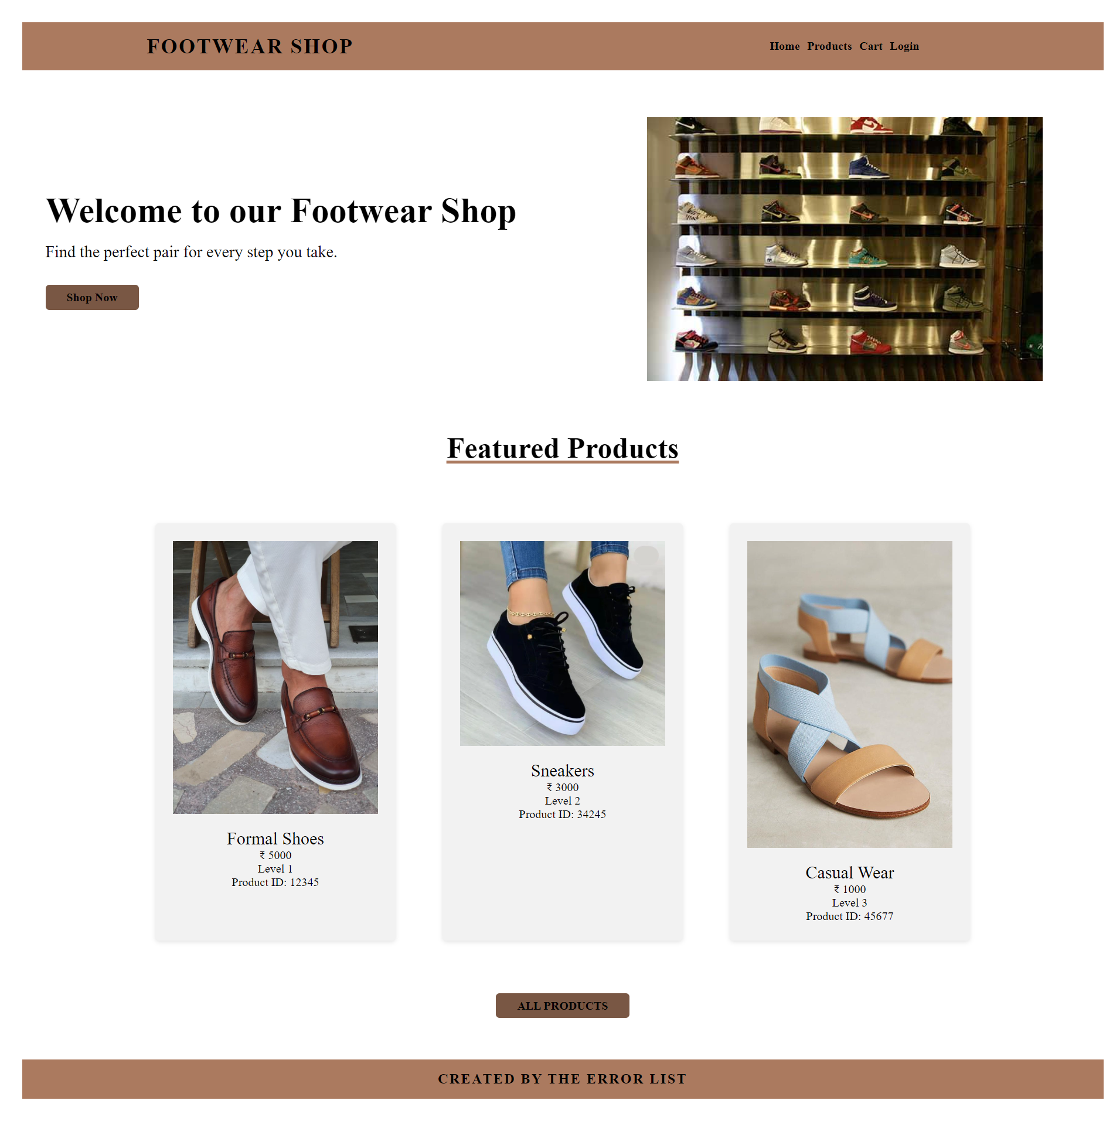

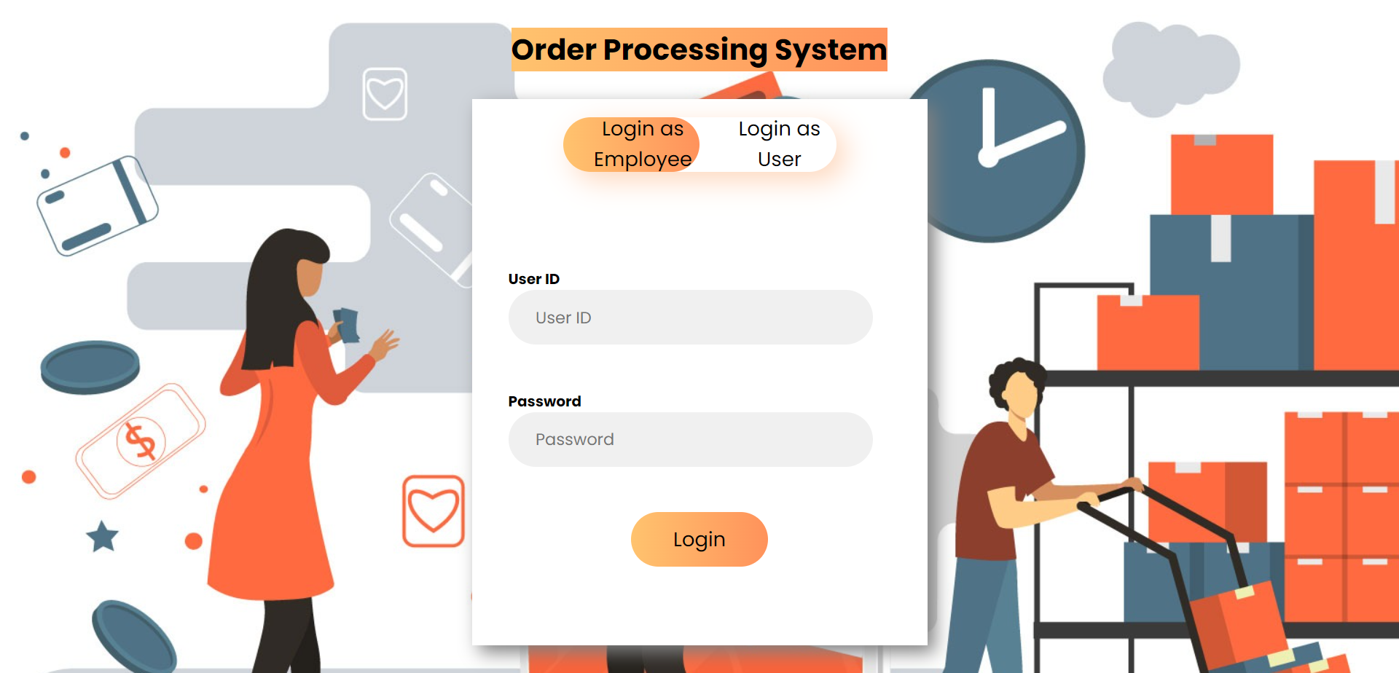

Dynamic Products Page

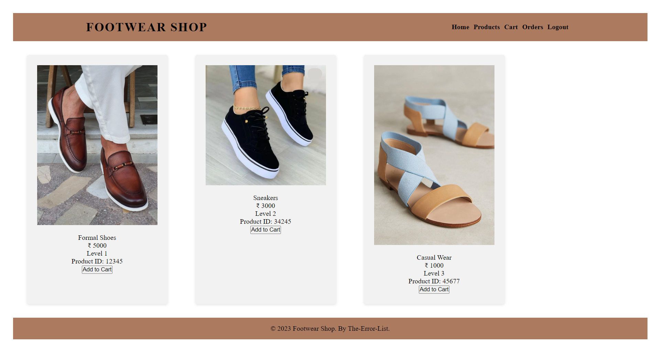

Cart Page

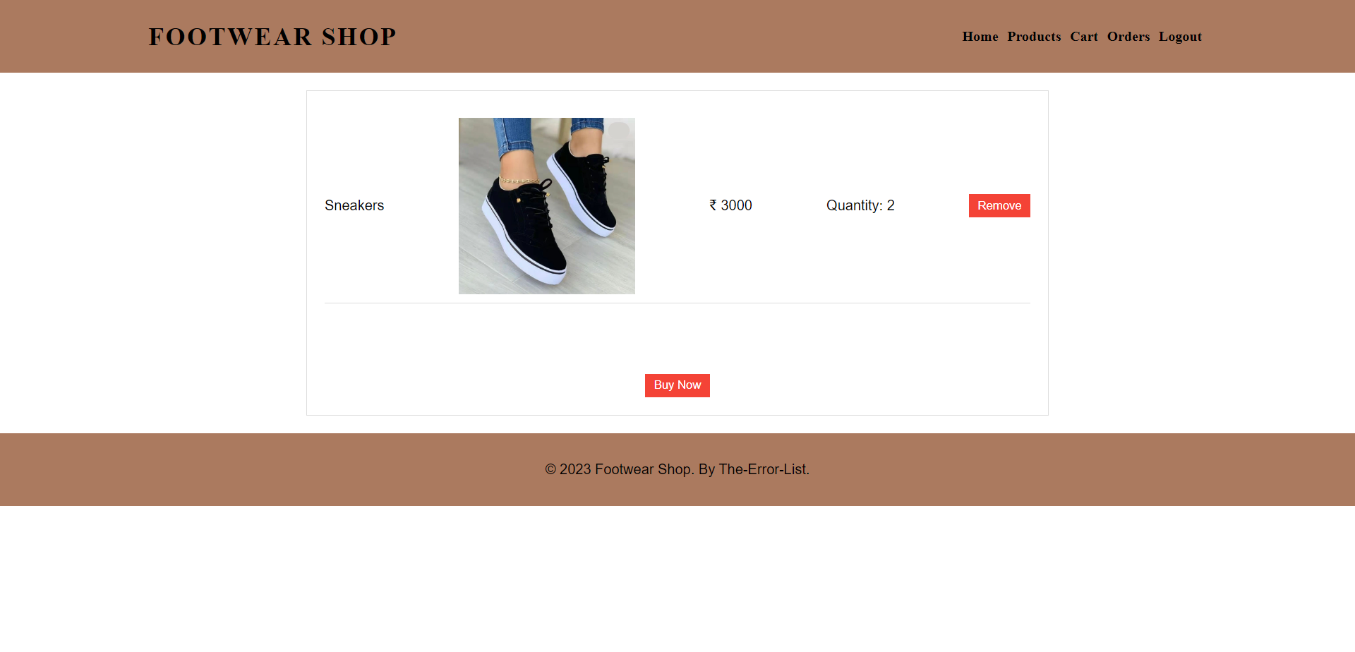

AFter placing cart order successfuly

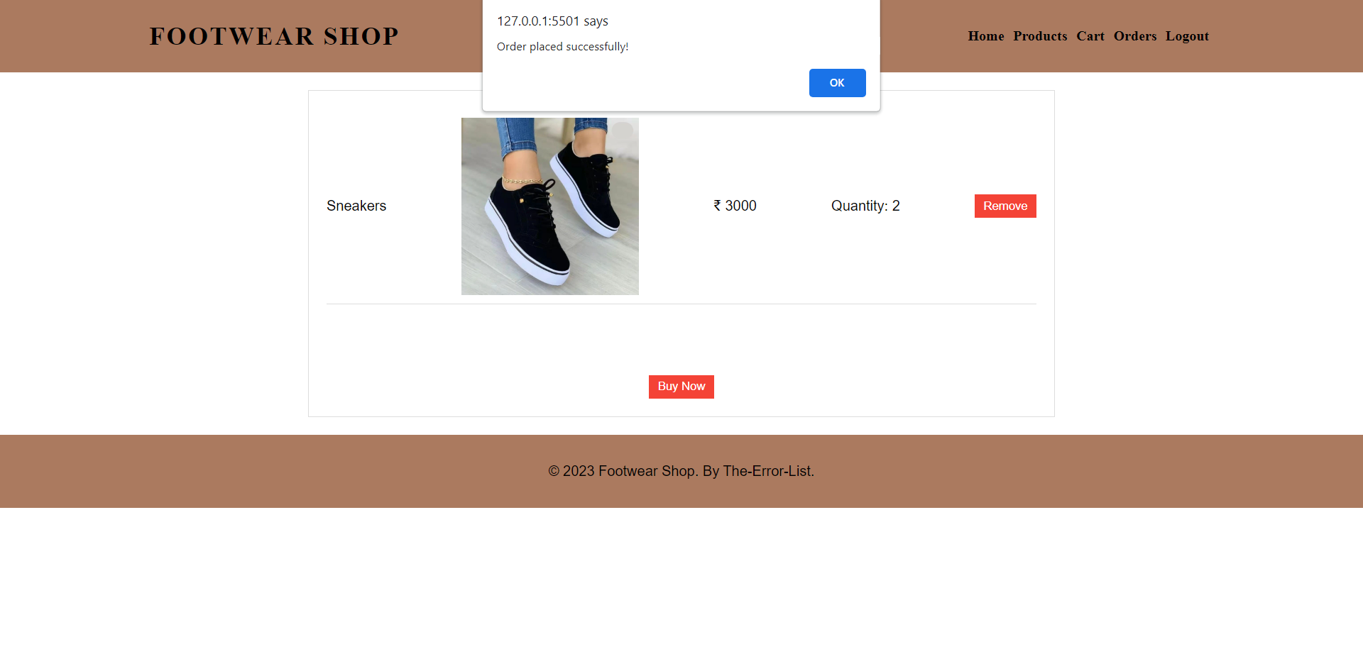

Getting the receipt of the Cart Items Ordered

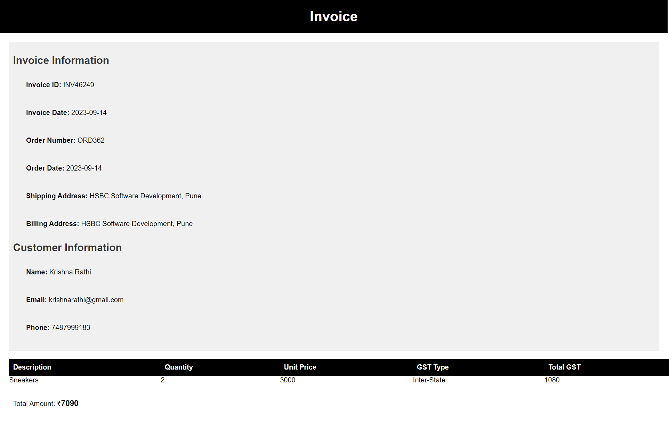

Hard Coded Orders Page

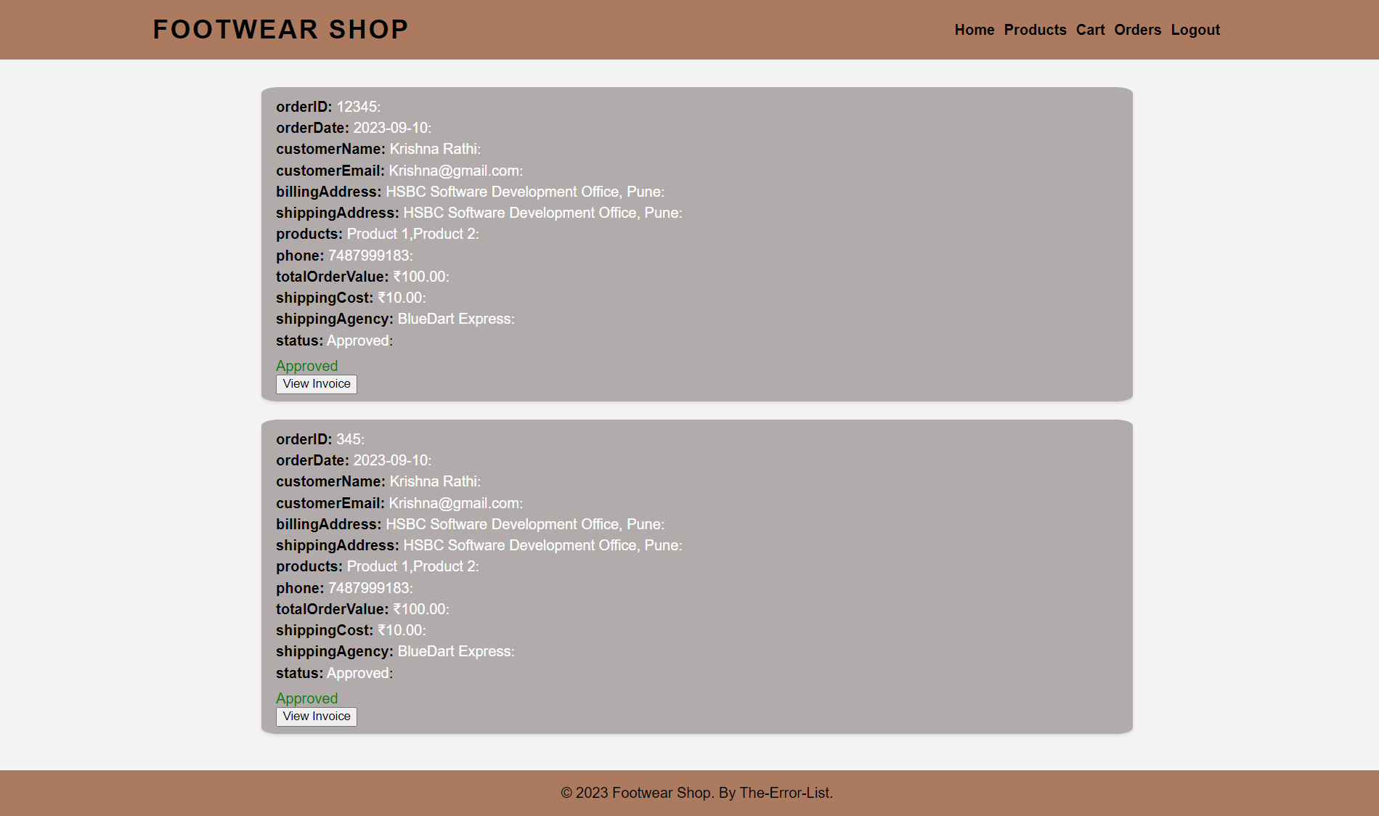

Receipt linked to the Particular Order

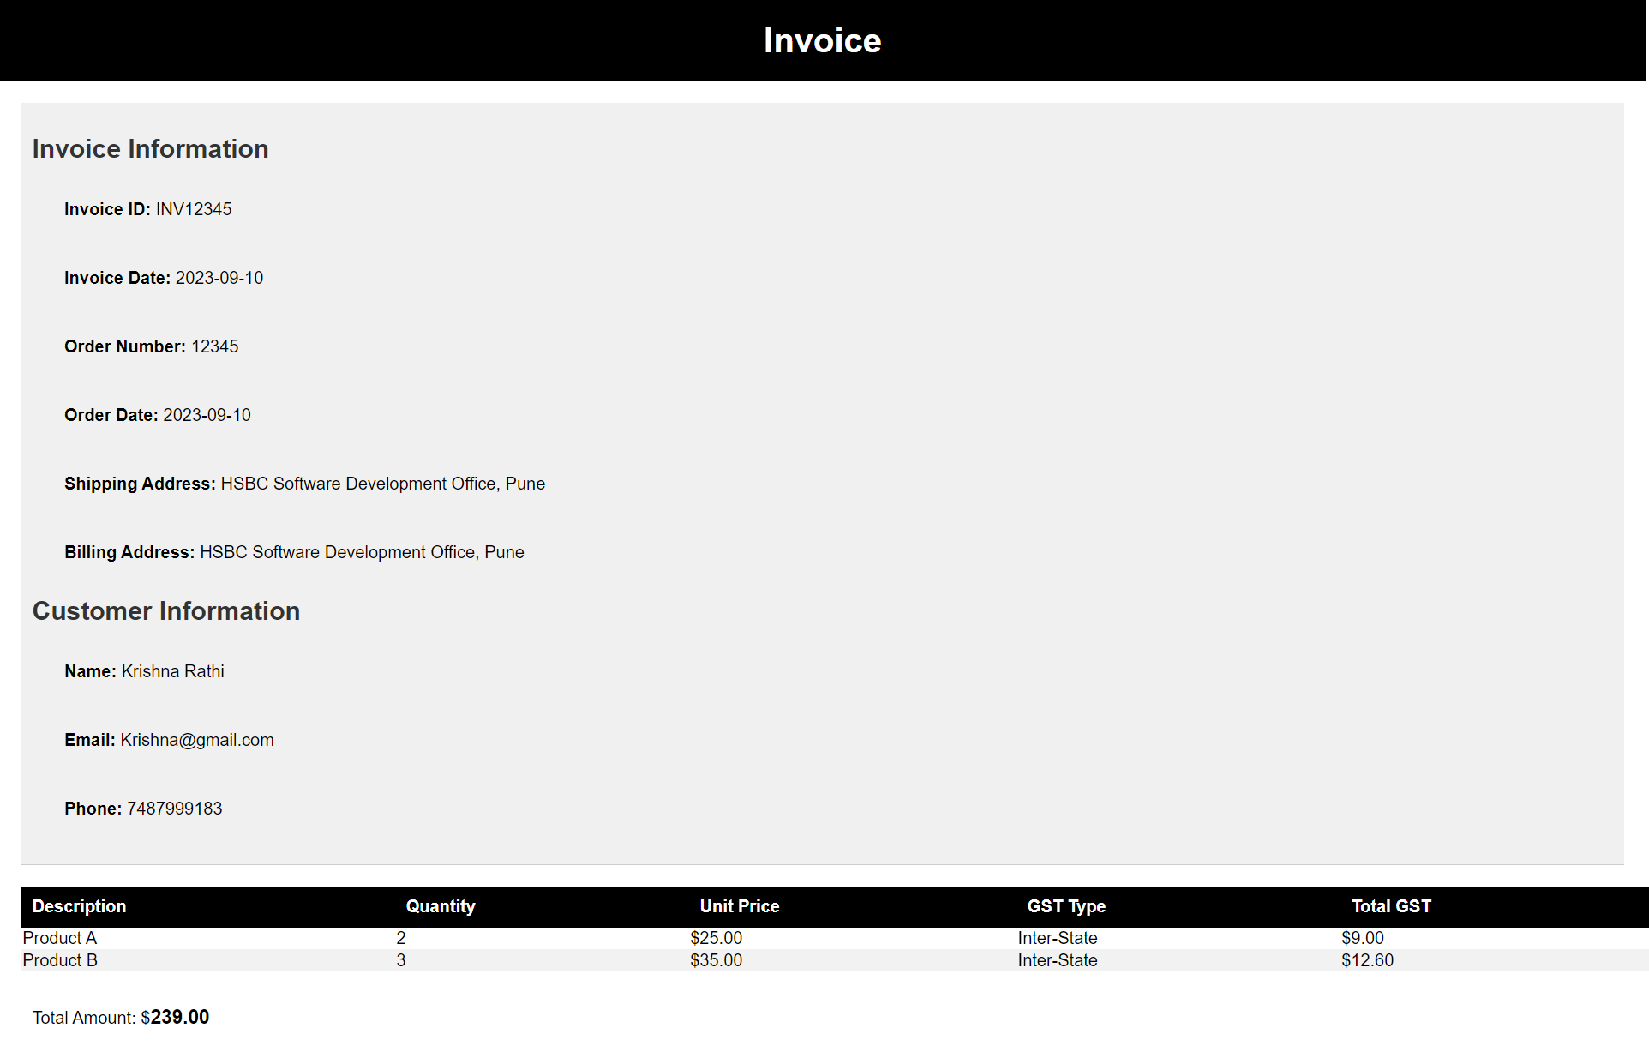

Token and authentication verification





EMPLOYEE VIEW

1. Employee Login

The Employee Login section is where employees can log in to access the system's features. The login form contains the following fields:

Employee ID: Unique identification for employees.

Password: Secure authentication using a password.

Business Rules for Employee Login:

Employee ID and password must match the stored credentials.

An employee should not already be logged in to prevent multiple sessions.

Upon successful login, employees are redirected to the Order Management Page.

EMPLOYEE DASHBOARD

The Employee Dashboard HTML file is the foundation of a web application designed to provide employees with essential functionalities and information.

It begins with a declaration of its HTML5 structure, followed by a head section containing meta information, links to external stylesheets, and the web page title.

The body of the page includes a header with a navigation menu, a container for employee details and orders, and placeholders for dynamic content generated by JavaScript.

The page is brought to life with external JavaScript files for interactivity. This well-structured HTML file forms the backbone of the Employee Dashboard, facilitating user-friendly navigation and access to employee-specific information and tasks.

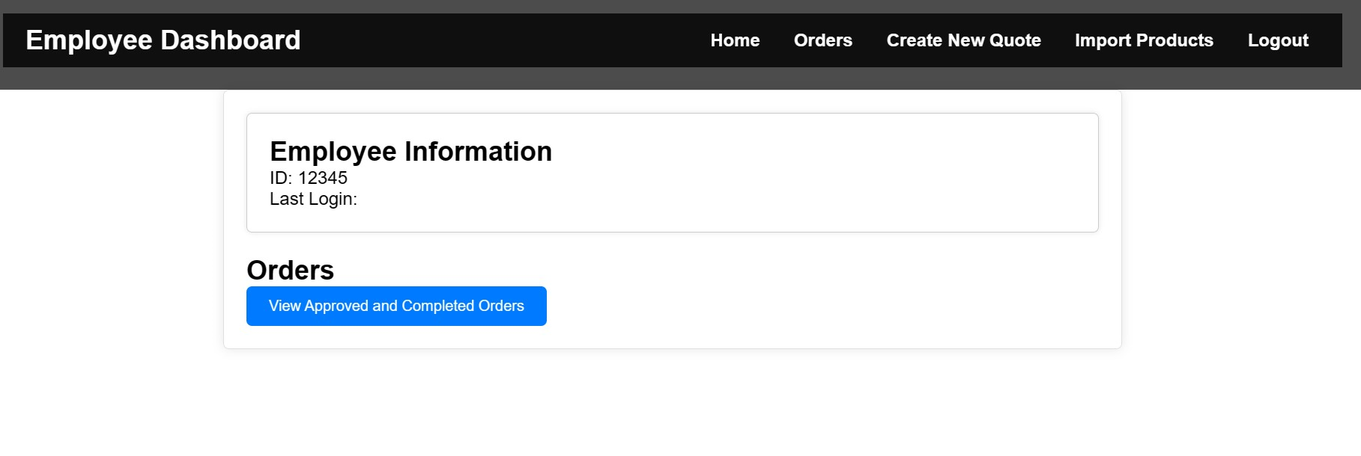

**─BACKEND—**

# Overview

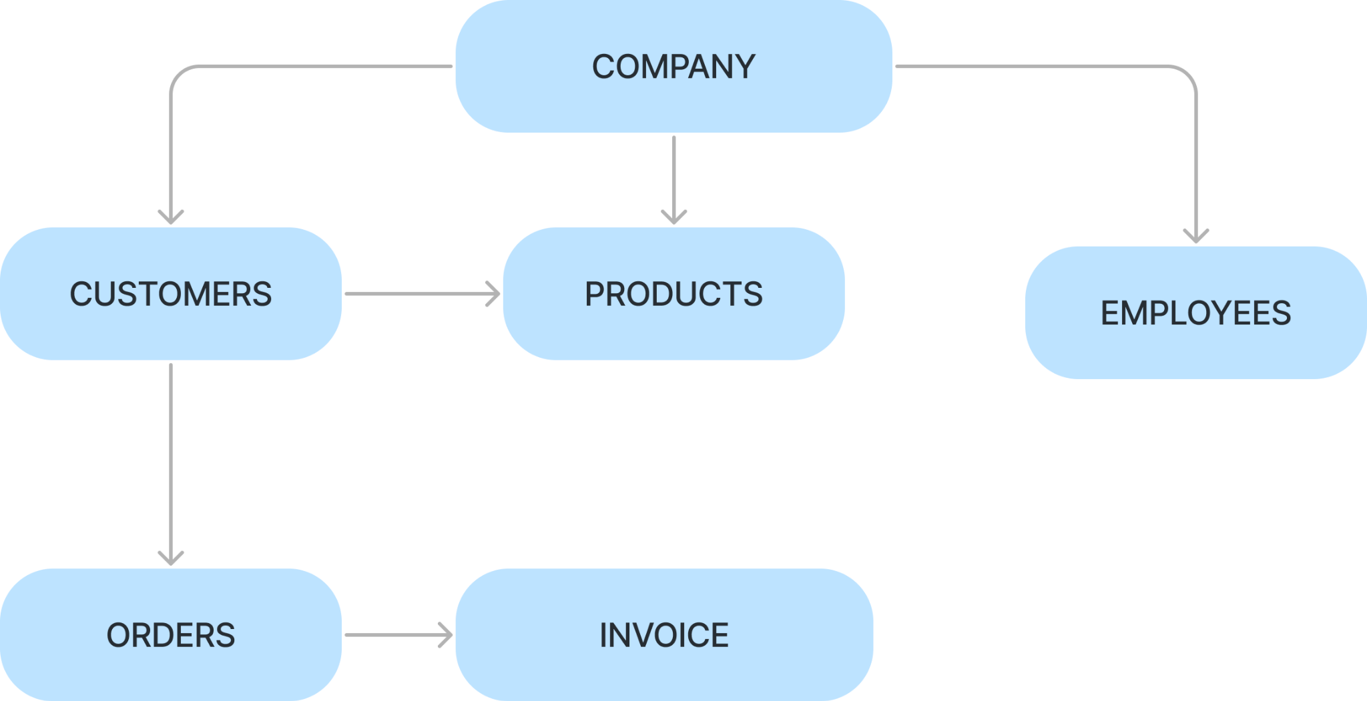

There are entities like company , customer , products ,employees ,orders and invoice.

* Company has Customers and Employees under it .
* Customers initiate orders for the products provided by the company.
* Every Customer has its own cart ( product with its quantity ) and this result in order and with the help of order entity , invoice is calculated .
* Invoices are created in accordance with the placed orders by Customer.

# Entity-Relationship Diagram

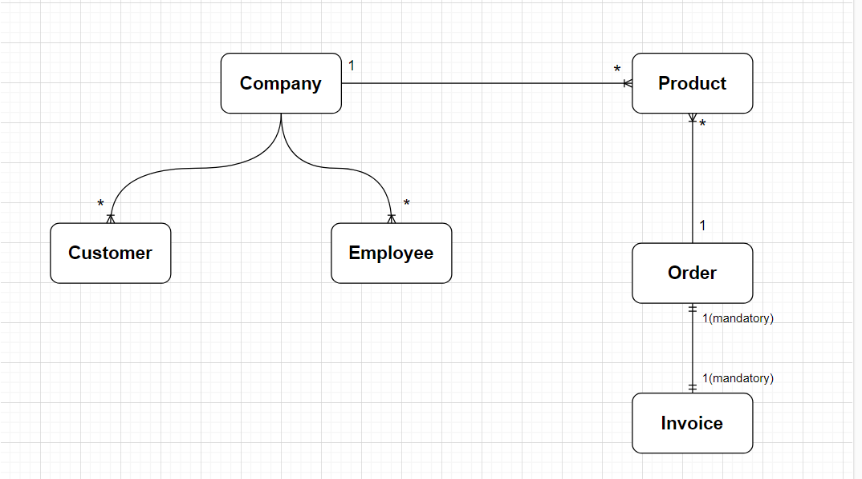

# 

# 

# 

# 

# 

# Customer

* Customer is capable of placing order

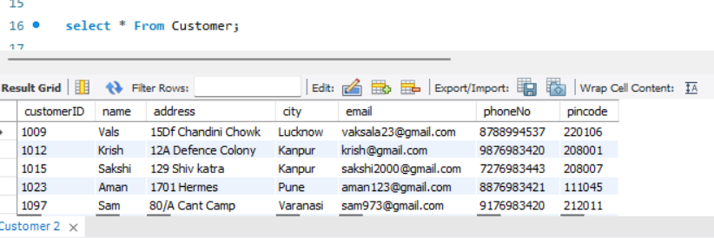

DataBase of Customer entity

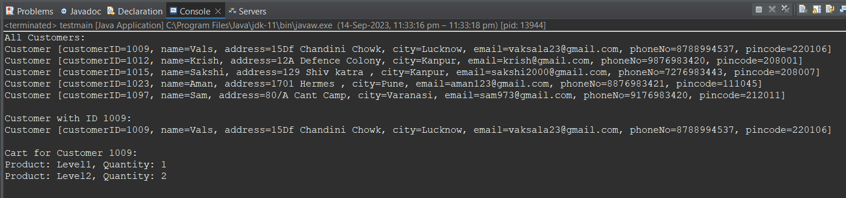

Backend checking of Customer Functions

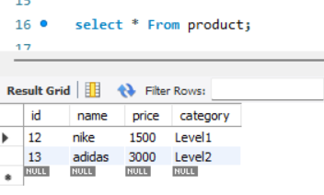

DataBase of Product Entity

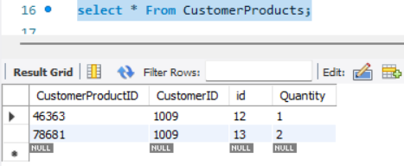

DataBase of CustomerProducts (Cart) Entity

# Company

Company is a static entity. Company has a name, address, city and GST number. The company has associations with all the other entities, viz. Products, Customers, Employees, Orders and Invoices.

# Product

Product has ID, name, price and category. The category decided the GST and shipping of products.



The function takes a list(set) of products and adds the product to the set. If product is added or not, we keep a running total of that. We pass 0, 0 in ‘productsAdded’ and ‘productsNotAdded’ as initialization.

Set is used so that there are no duplicate products. If a product already exists, it is updated.

# Employee

Employee has ID, username and password.



The function uses a JDBC connection to retrieve a list of all employees with their IDs and usernames from the database.

Again set here is used so as to avoid any duplicates.

# Order

Order has ID, orderdate order status etc with all other details importing from customer such its address and phoneNo;.

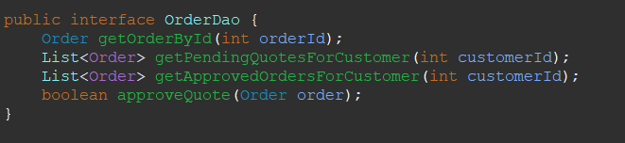

The function uses a JDBC connection to retrieve the details .Again boolean is used so as to

Conform the order quote.

# 

# 

# Invoice

Invoice class is dependent on customer,product and order class for retrieving the details,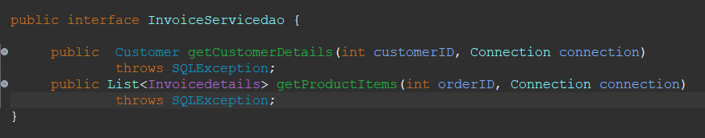

It uses a JDBC connection to retrieve the details from different classes and calculate the bill and gst accordingly .

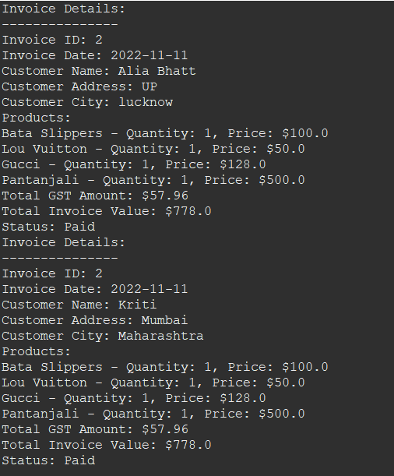

# Future Scope

1.International Expansion:

Consider expanding the business to international markets, including multi-language and multi-currency support.

2.Payment Options:

Integrate a wide range of payment options, including digital wallets, cryptocurrencies, and buy-now-pay-later services to accommodate diverse customer preferences.

3.Security Enhancements:

Regularly update and strengthen security measures to protect customer data and financial transactions.